Title: Communicating your findings to ‘hard to reach’ public audiences: Lessons from Indigenous health research translation and social marketing.

Name: Johanna Bell

Abstract
To maximise an evaluation’s influence, key findings need to influence change across a range of areas including policy, practice, knowledge advancement and behaviour change. While commissioned evaluations are often geared to directly influence policy and practice, less attention is paid to their potential for directly influencing the public’s attitudes and behaviour. This paper looks at how health research translation models and social marketing principals can be used to increase the reach and influence of evaluation findings, particularly among Indigenous populations. Three innovative case studies from Menzies School of Health Research will be used to illustrate different strategies for translating evaluation findings to audiences beyond the realms of policy and program management.

Introduction
Increasing an evaluation’s influence involves maximising awareness and understanding of findings among multiple audiences. Currently, evaluators of social interventions are well-versed with communicating findings for policy makers and program providers, but less practiced at translating findings to broader audiences. This is no accident. Leading evaluation theorists such as Stufflebeam, Wholey, Alkin and Owen have constantly reminded us about the importance of centralising the primary audience in the design and delivery of evaluations (Alkin & Christie, 2004). Since the primary audience is often also the commissioner of the evaluation, it is not surprising that evaluators’ efforts to disseminate findings are often focused on meeting the needs of the primary audience. But in our rush to respond to the primary audience, we risk overlooking opportunities to translate findings to other audiences, namely participants, practitioners, the broader public and our peers. You might ask “Is it the responsibility of evaluators to translate findings to these audiences? Shouldn’t the commissioner of the evaluation be responsible for disseminating findings to these groups?” In this paper, I use personal reflections and three case studies from the Menzies School of Health Research to highlight the benefits of increasing evaluator involvement in multi-audience knowledge translation. I also outline key lessons from biomedical knowledge translation and social marketing which have relevance for evaluators interested in ensuring their findings influence audiences other than evaluation commissioners.

Written evaluation reports – a blessing and a curse
As an early-career evaluator, I learned quickly that the written evaluation report is king. It would be unusual to conduct a sizeable evaluation without producing a written evaluation report. This is not surprising given evaluations are commonly commissioned by agencies involved in policy design or program provision. Written reports are aligned with the language and cultures of these agencies and provide a useful way of translating evaluative findings from evaluators to commissioners. However, evaluation reports can be a blessing and a curse for evaluators: a blessing in that they are familiar to both commissioners and evaluators and provide a common language by why to present evaluation findings; a curse because they blinker both evaluators and commissioners from alternative knowledge translation mechanisms and make the choice of a written report automatic rather than informed. In our haste to produce an evaluation report which meets the commissioner’s needs, we forget to ask whether this communication format is also an effective mechanism for translating findings beyond the domains of policy and program management. While many evaluators would agree that evaluation reports are a good medium for presenting evaluation findings to policy and program management audiences, they are not necessarily accessible, relevant or appealing to other key audiences such as practitioners, evaluation participants and the broader public, who could also benefit from learning about an evaluation’s results.

Encouragingly, evaluation theorists such as Patton, Cousins and King have urged evaluators to conceptualise the translation of evaluation findings as a process rather than a product (Alkin & Christie, 2004), drawing focus away from the evaluation report and placing it on participatory processes such as presentations, workshops, seminars and training sessions. However, in my experience, these participatory processes tend to be presented as accompaniments to the written report and are typically targeted at policymakers and program providers. Less, if any, consideration is given to translating findings to secondary or tertiary stakeholder groups.

Beyond the written evaluation report: Why bother going there?
Communicating evaluation findings to multiple audiences is more expensive and resource intensive than delivering findings to one primary audience, so why bother investing in a multi-audience translation strategy? The reasons relate to maximising influence, ethical responsibility and business opportunities, each of which is explained below.

Increased reach and influence
At its heart, evaluation is about social betterment, and one of the main vehicles used by evaluators to achieve social betterment is our capacity to influence change in policy, organisations, programs, projects and individuals. In short, the broader an evaluation’s reach, the greater the potential for influencing change. Evaluators want to ensure that the work they do is utilised and what better way of assuring this than through the creation of a divergent translation strategy. Instead of delivering findings to one audience via a single format (e.g. a written report), evaluators can increase the potential that their findings will be utilised by designing translation strategies for multiple audiences. In doing so, evaluators diminish the risk that their evaluation’s influence will cease if someone, somewhere decides to shelf the evaluation report. The tenuous relationship between evaluation and politics is well documented and the threat presented by changing political backdrops is a danger for evaluators who have placed all their translation strategies in a ‘single-audience, written report’ basket. By reducing dependency on the written report and the primary audience for disseminating evaluation findings, evaluators can effectively insure themselves against the risk that their findings could be shelved.

A more ethical response
Another key reason for actively communicating findings beyond the primary audience relates to ethics. The Australasian Evaluation Society’s Guidelines for the Ethical Conduct of Evaluations states that “The results of the evaluation should be presented as clearly and simply as accuracy allows so that clients and other stakeholders can easily understand the evaluation process and results,” (AES, 1997, p.12). Similarly, the Society’s Code of Ethics states that “Members should consider the interests of the full range stakeholders in their evaluation work, including the broader public interest, and in particular, the potential impacts of differences and inequalities in society” (AES, 2000, p.2). Similar themes have been reiterated by bodies such as the American-based Joint Committee on Standards for Educational Evaluation who outlined in their 1997 propriety standards that evaluation findings should be made accessible to all persons affected by the evaluation and any other parties with expressed legal rights to the results (Sanders, 1994). The common messages across these statements are that evaluators have an ethical responsibility to deliver findings to evaluation participants and broader stakeholders in a format which is accessible, understandable and accurate.

Prioritising the communication of evaluation findings beyond policymakers and program managers also has the potential to improve the standing and reputation of the evaluation industry. In particular, the consistent provision of findings to evaluation participants and other interested stakeholders has the potential to increase trust in evaluators and undo any damage done by evaluators who have not provided feedback. One of the common criticisms of evaluators in remote Indigenous contexts is that they take away information but fail to provide any feedback to evaluation participants or other interested parties at the community level. This practice has contributed to well-documented evaluation fatigue among Indigenous populations who are tired of being continually consulted without any feedback or follow-up (ALRC, 2010, DEECW, 2010). By locating the responsibility of the provision of findings with evaluators rather than commissioning agencies, we as a community of evaluators can help to ensure that those who contribute to evaluations are provided with targeted information about key findings and outcomes. Over time, this will improve our reputation as responsible and ethical evaluation providers and assist in sustaining the good quality relations on which effective evaluations depend.

Utilising evaluators’ established relationships
Another reason why the translation of evaluation findings to multiple audiences should be the core business of evaluators is because we are in a strong relational position to do so. During the life of an evaluation, evaluators develop working relationships with a range of stakeholders including collaborators, commissioners, service providers and service users. These relationships differ in depth and breadth depending on the evaluation approach used, but provide potential springboards for the delivery of information about evaluation findings. In other words, evaluation practitioners are particularly well placed to reach a range of stakeholder groups because of pre-existing relationships developed during the course of an evaluation. These relationships provide a ‘natural window’ for disseminating key findings, especially where accessing ‘hard to reach’ audiences such as Indigenous and culturally and linguistically diverse communities are concerned. For example, if an evaluator has developed a strong, working relationship with an Indigenous health worker during the course of an evaluation, this individual provides entrance point for the provision of information to service users or research participants. Similarly, if a partnership with an individual school has been forged during an evaluation, existing relationships with the principal and teaching staff provide natural opportunities for disseminating evaluation findings to other staff, parents and students. Unlike an evaluation report, these relationships can not be ‘handed over’ to a commissioning agency at the end of an evaluation. If evaluators are not directly involved in communicating evaluation findings to multiple audiences, there is a risk that these opportunistic avenues for communicating key findings will remain unutilised.

Creating new evaluation business
Lastly, by taking responsibility for the dissemination of findings to multiple audiences, we are creating a new area of specialisation for evaluators and the evaluation industry. Currently, commissioners often request that evaluators present findings in a written report, after which the evaluation is considered complete. By prioritising the translation of findings to multiple audiences and positioning evaluators as experts in knowledge translation, the evaluation ‘lifecycle’ is extended and so too is work for the evaluator. This reframing will likely require evaluation professionals to encourage those responsible for commissioning evaluations to see the benefits of resourcing evaluation translation to multiple audiences.

Translating findings to audiences other than policy makers and program managers
If we agree that having evaluators involved in the translation of findings to multiple audiences is beneficial, the next logical question is ‘how do we translate the findings to diverse audiences?’ Inspiration and lessons can be drawn from knowledge translation work being conducted in the biomedical research field. The research translation model used by the University of Kentucky, suggests that sustained change is dependent on influencing five ‘impact metric’ areas: government (policy), health professionals (practice), the public (behaviour), academia (knowledge advancement), and industry (application), (University of Kentucky, 2011). Each of these audiences has its own culture, processes and protocols which means that influencing change requires the translation of findings so that they are accessible, understandable and relevant for individual audiences. This user-driven philosophy is also reflected in social marketing principles and practice. Intent on changing behaviour through education, motivation and advocacy, social marketers are acutely aware of ‘consumer orientation’ and the need to develop key messages for specific populations (Donovan & Henley, 2003). The following three case studies highlight lessons from biomedical research and social marketing which have relevance for evaluators interested in broadening the reach and influence of their findings. Designed specifically to reach Indigenous audiences, the case studies also provide examples of strategies for communicating findings to audiences who might otherwise be excluded due to barriers such as remoteness, service disengagement and low English literacy.

Case Study 1: The Mobile Preschool Research Translation Model – using a biomedical research model to frame evaluation translation
The Mobile Preschool Program evaluation, a quasi-experimental study, found that increased preschool attendance is associated with increased school readiness among Indigenous five year living in remote Northern Territory. The Mobile Preschool evaluation team wanted to ensure that research findings reached four distinct audiences: policymakers (in relevant Northern Territory and federal government departments); practitioners (principals, teachers, assistant teachers and other professionals working in remote early childhood education); the public (in particular, the carers of remote Indigenous children); and, academics (primarily those working in education and health research). The University of Kentucky’s biomedical research translation model was adapted to create a multi-audience translation framework and specific communication strategies and products were designed for each target audience. Figure 1 provides an overview of the framework used.

Figure 1 – Research Translation Model used for the Mobile Preschool Evaluation

One of the benefits of using the biomedical research translation model for framing the Mobile Preschool Evaluation’s translation process was its distinct separation of policy and program management from other translation audiences. This model encouraged evaluators to consider all four audiences, discuss the differences between each and identify targeted communication strategies for each discrete audience. The inclusion of the public as a primary translation audience encouraged evaluators to think about creative ways to communicate research findings to parents living in remote communities who were unlikely to benefit from translation strategies for other audiences. The focus on practitioners encouraged evaluators to identify a range of discrete practitioner roles, each of which was considered in the development of targeted translation strategies. For example, evaluators acknowledged that school principals had different priorities, skills and information delivery preferences compared with Indigenous assistant teachers, resulting in the development of a translation model which could accommodate for both. Principals were encouraged to attend regional workshops with there peers and evaluators met with assistant teachers in small groups to outline evaluation findings and implications with the aid of a purpose built flipchart. Figure 2 provides an overview of the targeted strategies designed for each audience. By locating the research translation process within the Mobile Preschool evaluation plan and by giving evaluators responsibility for designing and managing the translation process, evaluators were able to utilise many of the relationships, networks and contacts they had developed over the course of the two year evaluation.

Figure 2 – Overview of targeted strategies for Mobile Preschool Research Translation

Case Study 2: The Grog and the Brain Project – using multimedia products to translate findings
The Grog and the Brain Project aimed to translate addiction science into a format which was accessible, engaging and meaningful for two audiences: Indigenous people at risk of problem drinking; and professional intermediaries such as health workers, and alcohol and other drug (AOD) workers who support problem drinkers. A two minute animation was chosen to communicate targeted messages about the structure of the brain, the effects of long term drinking on different parts of the brain, and the changes to expect in the brain when drinking in reduced. A brain character, like the one outlined in figure 3 was used to establish rapport with the target audience and visually illustrate key addiction science messages. The major lesson provided by this case study relates to the importance of choosing a medium which is accessible, engaging and meaningful for the target audience. A short animation combines visual and audio material with character development and narrative, making it an ideal format for translating complex brain science information to Indigenous audiences with varied literacy skills. Animations can also be easily adapted to accommodate for different languages, particularly relevant for those working with Indigenous and culturally and linguistically diverse audiences. Aside from the English version, the Grog and the Brain animation was translated into three Indigenous languages with future translations planned. Multimedia products can also have particular appeal with sub-groups such as young people, who may be difficult to reach through traditional forms of information dissemination such as written reports, media coverage, and products such as brochures. Another key lesson from the Grog and the Brain case study relates to the role of the evaluator (or in this case, the researcher) in the animation development. In this example, a neuroscientist was involved in the key message development, scripting, focus testing and character creation to ensure that key messages were not diluted or misrepresented. Given that evaluators have often worked on projects for long periods of time and have a deep understanding of the subject and findings, they too are well placed to work alongside multimedia professionals to ensure that products effectively communicate key findings.

Figure 3 – Screen grab from Menzies’ Grog and the Brain Animation
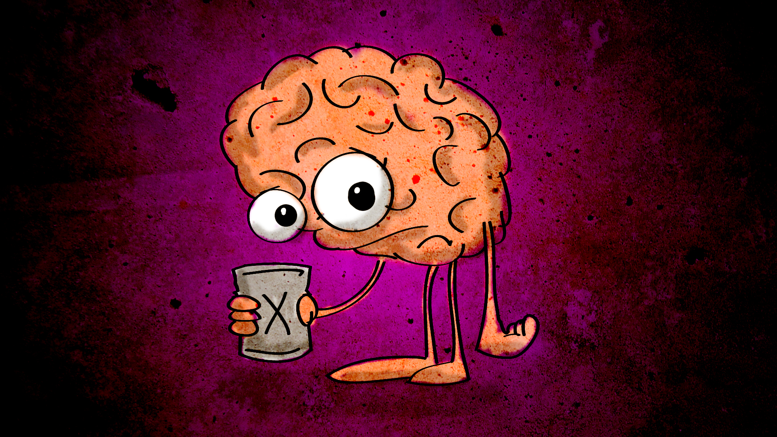

Study 3 – The Australian Early Development Index – centralising culture in the translation process
The Australian Early Development Index (AEDI) is a national census of five year olds designed to collect population-level data on child development. The findings provide a national picture of children’s health and development and are used by government, communities and schools to better understand and respond to communities’ needs. Menzies, in partnership with the Northern Territory Department of Education has developed a culturally relevant, two-way translation process designed to raise awareness and understanding of AEDI findings in remote Indigenous communities. The translation process involves a half-day, strengths-based workshop centred on ‘The Cultural Eye,’ an interactive art work created by Indigenous health researcher and artist, Anne Hanning (Figure 4). ‘The Cultural Eye’ provides a visual and cultural reference point by which Bronfenbrenner’s ecological model of child development (Bronfenbrenner, 1979), and the AEDI results are interwoven with participants’ existing knowledge of child development. A series of practical brain development activities are used to further aid the translation of AEDI data and child development principles. This translation framework allows AEDI findings to be presented via a locally-specific narrative created with participants. Ownership of the findings is collectively shared and participants are encouraged to share their new understanding with their family and peers. The AEDI research translation process provides a strong example of how evaluation translation can overlap with education or capacity development activities. Evaluators in these contexts are not simply ‘analysing and reporting’ on findings but drawing on skills in facilitation, cross-cultural communication and adult education to transfer findings effectively. The AEDI case study also demonstrates the importance of centralising culture in cross-cultural knowledge translation processes and using a strength-based approach, both of which are key to effective cross-cultural communication (Scougall, 2008).

Figure 4 – ‘The Cultural Eye’ workshop process
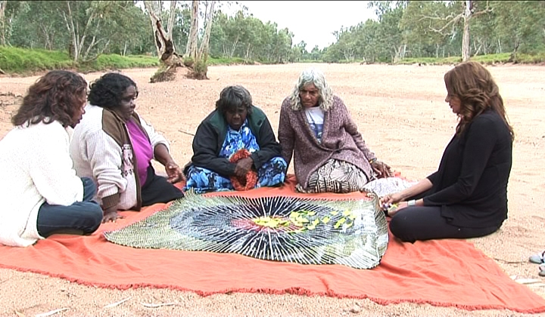

Conclusion

If we are genuinely interested in maximising the influence of our evaluation work, we need to conceptualise knowledge translation as more than the delivery of a written evaluation report. While creating a translation product which meets the needs of the primary audience is important, as evaluators, we have an ethical responsibility to ensure that broader audiences can access evaluation findings. In particular, efforts should be made to create tailored products to communicate evaluation findings to individuals and groups who have contributed to the evaluation process. Where this involves participants from Indigenous or culturally and linguistically diverse backgrounds, evaluators could consider the use of purpose-made multimedia resources or culturally relevant translation processes. Evaluators could also consider greater use of biomedical research translation models and social marketing approaches as they offer ready-made frameworks for translating evaluation findings to multiple audiences. Increasing the role we play in knowledge translation has potential benefits for the evaluation community, in particular, greater reach and influence, an enhanced reputation as ethical operators, a new area of specialisation and increased work for evaluators.

References

Alkin, M & Christie, C. 2004, An Evaluation Tree: Chapter Two, Sage, Viewed 14 July 2011, <http://www.sagepub.com/upm-data/5074_Alkin_Chapter_2.pdf>
Australian Early Development Index (AEDI), 2010, About the AEDI, viewed 14 July 2011, <http://www.rch.org.au/aedi/index.cfm?doc_id=13051>
Australasian Evaluation Society (AES), 1997, Guidelines for the Ethical Conduct of Evaluations, viewed 14 July 2011, <http://www.aes.asn.au/about/Documents%20%20ongoing/guidelines_for_the_ethical_conduct_of_evaluations.pdf>
Australasian Evaluation Society (AES), 2000, Code of Ethics, viewed 14 July 2011, <http://www.aes.asn.au/about/Documents%20-%20ongoing/code_of_ethics.pdf>
Australian Law Reform Commission (ALRC), 2010, Approach to Inquiries – Consultation, viewed 14 July 2011, <http://www.alrc.gov.au/publications/3.%20Approach%20to%20Inquiries/consultation>
Bronfenbrenner, U, 1979, The Ecology of Human Development: Experiments by Nature and Design. Harvard University Press.
Department of Environment, Climate Change and Water (DECCW), 2010, Northern Rivers Regional Biodiversity Management Plan: Appendix 7. Indigenous community consultation, Viewed 14 July 2011. <http://www.environment.gov.au/biodiversity/threatened/publications/recovery/pubs/northern-rivers-appendix-7.pdf>
Donovan, R & Henley, N, 2003. Social Marketing: Principles and Practice. IP Communications, Melbourne.
Sanders, J. (chair), Joint Committee on Standards in Educational Evaluation, 1994. The Program Evaluation Standards: How to Assess Evaluations of Educational Programs. 2nd Edition. Sage Publications, Thousand Oaks, CA.
Scougall, J. 2008, Occasional Paper No. 19: Lessons learnt about strengthening Indigenous Families and Communities: Stronger Families and Communities Strategy 2000-2004.
University of Kentucky, Research Translation Core, 2011. UK-SBRP Research Translation Model, viewed 14 July 2011. <http://www.uky.edu/WaterResources/EPABooklet.pdf>

