DRIVING DEVELOPMENT ADVOCACY – A ROLE FOR EVALUATION

Paper Number 348.00

ANDREW NEWMARCH
WORLD VISION AUSTRALIA

andrew.newmarch@worldvision.com.au

Paper presented to the Australasian Evaluation Society international Conference, Sydney, Australia, 29 August – 2 September 2011

The views presented are those of the author rather than the organisation.

Abstract

World Vision has had some success implementing advocacy projects seeking to change policy and produce systemic reforms in a selection of Eastern Europe and Middle East countries. However, there has been a frustration with how to measure and report on the outcomes of projects’ activities. Advocacy is a complex business and does not sit easily in the linear, cause and effect approaches to monitoring and evaluation systems in which much development work is framed.

Thus, the influence we’re concerned about is both internal – better evaluation approaches – and external – telling the advocacy story more effectively.

A better understanding and use of evaluation techniques produced a theory of change map to provide a simple and visual way to capture the complexity of the advocacy work while simultaneously providing elements of linearity and room for flexibility and adaptation to changing circumstances. Mapping out the steps empowered the team to more clearly define and share their objectives and where they were heading. Moreover, adapting well-developed frameworks for advocacy capacity measurement enabled management to develop reports that captured essential information succinctly.

Introduction

World Vision is a large, international, faith-based aid and development agency that has shifted over time from a focus on orphanages to the embracing of systemic reform. Along this journey, the forms and categories of activity have been categorised as development, emergency and advocacy. As the agency has become more sophisticated and responded to changing ideas it has developed a framework to raise the level of rigour and consistency to bring equal focus to the competing claims of accountability and learning. Within the development and emergency streams of activity the systems and processes have been able to draw on a breadth of knowledge not available in the same way to the advocacy stream.

The global standard system for design, monitoring and evaluation of projects was called LEAP (Learning through Evaluation with Accountability and Planning). A core principle of this framework was systematic inquiry that included analytical, reflective learning but at the same time there was a requirement to organise design using a logframe. This was despite recognition elsewhere that there were limitations to the logframe and that “social development, rights and justice cannot be planned for, managed and delivered in a linear fashion”.

For those working in World Vision advocacy projects, this was particularly so. Specific factors constraining advocacy work were the demand for attribution, a long time frame needed for changes to occur, shifting strategies and milestones. Traditional social science methods, especially those that required static independent variables likely to be affected by another set of variables are not always well suited for measurement of advocacy. There appeared to be limited guidance regarding how to measure advocacy and policy work and, furthermore, there was the “belief among some advocacy organisations that their work cannot be measured and that any attempt to do so diminishes the power of their efforts”.

This formed the background to the challenge facing World Vision in evaluating its systems reform project.

Context of the operating environment

World Vision works in over 90 countries around the world. Organisationally, regional offices have been established to manage the work and this is so in the Middle East, Eastern Europe region, where World Vision works through 15 countries. Countries in this region have seen centuries of inequity. It is hard work to work in collaboration with other agencies let alone gain government trust to bring about systemic change. This change is directed particularly at the circumstances of children, particularly so they are better protected from disempowering institutions, violence, exploitation, abandonment and exclusion. World Vision is seeking to better leverage a range of programs and government good will and to model practical human rights.

Children suffer from social trends which are repeated throughout this region, including: conflict and violence; massive refugee displacement; human trafficking and labour exploitation; Roma as a severely marginalised minority group; child abandonment and decrepit institutional care; and the warehousing of disabled children. Across the region there is a general lack of good governance and citizen empowerment yet extremely ripe opportunities for change.

The challenge, however, is that implementing such reforms requires a new level of capacity building in our National Offices and with our partner organisations. This aligns with a key finding from an internal survey in 2009 revealing that monitoring and evaluation was also a challenge.

The evaluation challenge was to draw together the systems reforms activities and initiatives that were being considered. These covered:
- Policy reforms at national or provincial levels in both legislative and regulatory form;
- Scalable pilots, modelling the reform;
- Capacity building of WV staff as well as government and citizens to recognise and act on these initiatives;
- Public campaigning to promote adoption of the reform;
- Partnering with government and civil society; and
- Citizen empowerment and local level advocacy.

Given the range and complexity of activities and initiatives, there needed to be a structure to ‘see the whole picture’, and for this to provide the platform to select ‘ripe’ targets. These targets needed to be initiatives that had sufficient support and expertise within NGO coalitions, where there was a chance of government action and where it was felt that communities felt sufficiently empowered to engage in bringing about and sustaining change.

Developing a Management Toolkit

Theory of Change and Strategy Maps

The initial contribution of evaluation to this challenge was the development of a theory of change. Why this is so significant is that even though World Vision’s global DME framework alluded to theory of change, it was not a tool that was commonly practiced. However, it was essential that World Vision staff could understand and enunciate the systemic change processes relevant to their country contexts and advocacy issues.
Appendix A shows the theory of change mapping out three streams of advocacy activity ie government, coalitions (of NGOs) and community, all leading towards improved government service delivery. However, the foundation for these streams of advocacy is improved advocacy work which in turn is driven by advocacy capacity. This is the advocacy which needs to be measured and monitored.

An associated tool to map out stakeholders and systems was the creation of one page visual diagrams called strategy maps. These assisted the process of strategy development for advocacy targets.

Research on effective advocacy capacity building

Although the theory of change mapping was highly instructive in assisting the team to better frame the vision of what the team were doing and wanted to do, it did not provide the framework for analysing advocacy as such. The problem facing the team was how to capture the bigger picture of advocacy and its various forms and identify the categories against which to measure activity, effectiveness and impact.

Research revealed three main documents that would provide guidance:

- What makes and effective advocacy organisation – A framework for determining advocacy capacity

This report sets out four critical capacities for both structure and implementation of advocacy: leadership, management, adaptability and technical. The contents of these capacities can be set out in a detailed capacity logic model which is really helpful for agencies like World Vision which have a global DME (Design, Monitoring and Evaluation) standard that includes logframes.

The TCC Group recommends a three-part approach for evaluating specific advocacy capacity in an organisation:
- Use of a quantitative assessment tool that specifically includes advocacy capacity;
- Interviews with key organisational personnel, utilising the framework and assessment results; and
- A qualitative reflection process to unpack the quantitative findings.

- A guide to measuring advocacy and policy

A key feature of this material was the identification of outcomes and that they could be not only express ‘forward progress’ but also be defensive, in that they held a position against change. Another dimension of these outcomes was that they could be categorised as short, medium and long-term and that sometimes the long-term outcomes were a product of a series of other outcomes.

A second key feature of this material was the emphasis on starting with a theory of change. The proposition offered by this material was that strategies and outcomes and goals could be interconnected in a logical map and that these strategies and outcomes could achieve a higher level of specificity. Moreover, these strategies and outcomes were couched in models that drove social as well as policy change.

Finally, there were practical features of this material, firstly, categorising types of outcomes; secondly, setting guidelines for evaluation plans; and thirdly, a sample of tools.

- Strengthening and measuring advocacy capacity of civil society organisations

The focus of this material was to address universal concepts in advocacy with the development of an Advocacy Index. The Index focuses on twelve issues from feasibility of policy change to sound financial management. A seven point coring scale is offered in order to establish a baseline and monitor progress from that point. It is assumed that an organisation using the material will self score but the material also recommends that the organisation submit themselves to a Support Organisation Assessment, an Advocacy Panel, and possibly also to their constituents, all using the same criteria. What is attractive about the scoring system is that average scores can generate a succinct picture of the organisation very quickly and simply – although it does run the risk of being simplistic if abused. Importantly, the material claims that advocacy is not only measureable but is both an art and a measurable science.

These frameworks have been distilled and led to the establishment of a management snapshot and a set of management indicators as the basis for managing for impact.

Management snapshot

The Management Snapshot is the result of a survey that examines the financial, staffing, and strategy features of a World Vision National Office. The survey is largely quantitative with a report that gathers information from 31 questions into the following categories:
- Financial resources
- Staffing – levels and reporting status
- Communications contact
- Advocacy reporting line
- Strategy
- Training and other assistance
- Child impact
- Advocacy targeting (12 questions)
- Stories of change

All this information can be summarised into approximately four pages and much of the material can be formatted into charts and tables. A snapshot like this can reveal that a country like Albania, amongst other things :
- Is working on several issues simultaneously
- Has led a national level campaign on anti-trafficking in the past as well as designing a national level child protection system for government adoption
- Had success in government adoption of legislation on child protection units in partnership with other agencies
- Is a place where advocacy only forms 7.7% of the World Vision National Office budget.

Management Indicators

The information gathered for this report uses the four basic capacities for advocacy recommended by the TCC Group and California Endowment, viz: leadership, management, adaptability and technical. A series of 26 questions are asked covering all four categories using key information interviews and then scored in a similar way to the Advocacy Index promoted by PACT Zimbabwe. The adaptation generated by World Vision has been to provide both a skill capacity score and a management capacity score for each question.
These scores can then be summarised into a summary score for each advocacy capacity and then for the country and again the report can be contained within four pages.

A quick check of report results reveals that advocacy leadership in World Vision Albania has a high rating for management capacity with 3.3 out of 4 and less skill capacity to identify ‘ripe’ issues for selection with 1.5 out of 4. Thus this skill deficit can be identified for capacity building or training.

Conclusion

The embracing of enhanced evaluation practices has given the advocacy team skills and confidence in a framework that will work for them. There is far greater clarity in the logic of the whole project generated from the theory of change. Not only was the process significant by conducting a workshop to identify and debate the logic chain but the diagram provides an easy reference tool

The theory of change process revealed that it was imperative to conduct a rigorous baseline data collection and that it was worth investing in research and experienced staff and consultants to design and collect the data. This has now produced a comprehensive, yet succinct, set of data across all 15 countries for each country and the region. This is the foundation for the monitoring and reporting system that will follow.

Evaluation is no longer just the domain of the abstract academic and advocacy is no longer considered immeasurable. The potential cynicism of the advocacy worker has been replaced by a sense of empowerment because they have tangible material in their hands that clarifies where they are at and where they still need to go. That is a substantial change in capacity already.

APPENDIX A
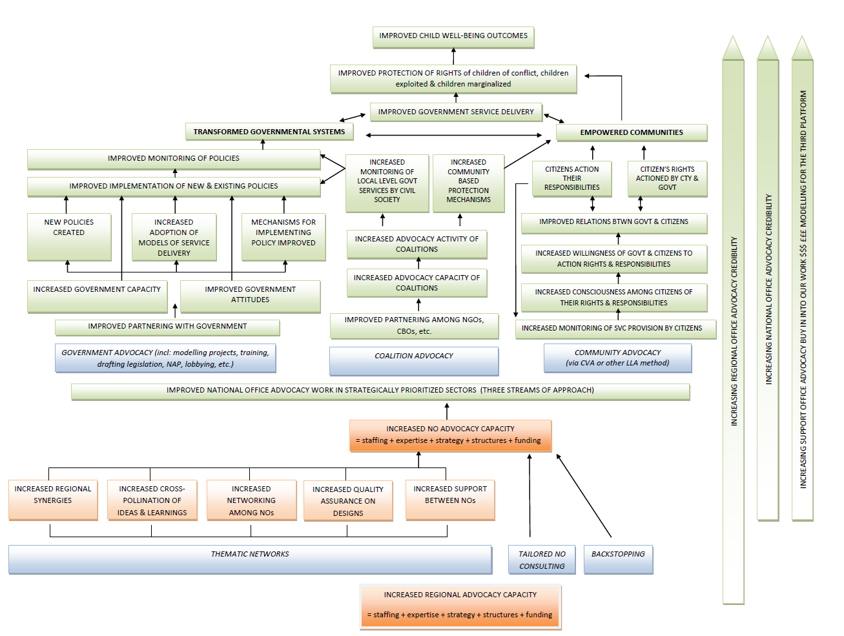

The original concept and abstract was written in conjunction with colleague Emma Pritchard, who is now taking maternity leave. Emma had a substantive role in evaluating the initial project and particularly in developing the theory of change that is the foundation of the second phase of the project.
David, Rosalind and Mancini, Antonella. 2005. ‘Going against the flow: the struggle to make organisational systems part of the solution rather than part of the problem – the case of Action Aid’s Accountability, Learning and Planning System’. Lessons for Change, Institute of Development Studies, Sussex, pp 1-28.
Reisman, Jane; Gienapp, Anne; and Stachowiak, Sarah of Organisational Research Services. 2007. A guide to measuring advocacy and policy. Funded by and prepared for Annie E. Casey Foundation. p.7. See: www.aecf.org
The areas of activity include: anti-trafficking (8 countries); deinstitutionalisation (6 countries); health (3 countries); citizen empowerment through an approach called Citizen Voice and Action (CVA) (6 countries); emergency advocacy; and ‘Children in Crisis’ reforms eg corporal punishment, disabilities and education.
Raynor, Jared; York, Peter; and Sim, Shao-Chee of the TCC Group. 2009. What makes an effective advocacy organisation – A framework for determining advocacy capacity. Funded and prepared by The California Endowment. See: www.tccgrp.com and www.calendow.org
Reisman, op.cit.
Hansen, Rene; Phute, Thembile; Dembe, Killron; Chikanza, Synodia; Rigby, John; and Bloom, Evan. 2005. Strengthening and measuring advocacy capacity of civil society organisations. PACT Zimbabwe Best Practice Series. See: www.pactworld.org

