Theme: Influences shaping evaluation

Title: How complexity influences evaluation
Author: Julie McGeary, Victorian Department of Primary Industries
julie.mcgeary@dpi.vic.gov.au

Paper presented at the Australasian Evaluation Society International Conference, Sydney, Australia, 29 August – 2 September 2011.

Abstract
This paper explores the way complexity concepts have influenced the shape of an evaluation of a large Victorian Government strategy.

The Future Farming Strategy (FFS) is a whole-of-government suite of support for the farming sector and regional Victoria which aims to improve farm business capacity to become even more productive, competitive and sustainable. The FFS can be considered to be a ‘complex intervention’ introduced into a ‘complex system’. In order to design a meaningful evaluation for the FFS which is delivered by six government agencies across 20 diverse initiatives, a literature review was conducted to gain an understanding of the implications of complexity for evaluation planning.

The paper discusses the major issues emerging from the literature review, which include characteristics of complex systems, aspects of complex interventions, and how the interaction between systems and interventions can be the most significant aspect of complexity. The role of program theory in complex strategy evaluation also emerged as an important issue, as did reconciling the tension between forms of evidence that evaluation audiences deem credible, and forms of evidence that complexity renders feasible.

An overview of FFS evaluation planning is then outlined, with design decisions justified by reference to the learnings emerging from the literature review.

Introduction
The Future Farming Strategy (FFS) represents an investment by the former Victorian Government of $205 million over four years across six departments. Through additional funding, new approaches to service delivery and new policy approaches, FFS aims to develop farm business capacity to improve risk management, participation in markets, decision making and adoption of new and further developed technologies and practices, enabling Victorian farm businesses to become even more productive, competitive and sustainable (DPI 2008).

The strategy includes 20 funded Actionsand also identifies 14 further Actions that, while not directly funded through the FFS investment, are linked to the aims of the strategy. All funded Actions are expected to conduct Action level evaluations, and are free to develop their own evaluation approach that most suits their project.

The logic model for FFS (Figure 1) shows a hierarchy of outcomes from short-term to long-term, in the sequence in which they are expected to be achieved from the FFS inputs. It also shows where in the hierarchy government responsibility for outcomes shifts from accountability to influence.

The difficulties associated with designing meaningful evaluations for complex strategies are a consequence of the increasing complexity of the modern policy environment. Using a definitional lens of complexity, the FFS is an example of a complex strategy, and evaluation planning for FFS has attempted to account for this complexity.

A review of the recent evaluation literature was undertaken to improve understanding of several key issues influencing the FFS evaluation design. The first issue concerned complex system characteristics of the Victorian agricultural sector, complex aspects inherent in the FFS intervention, and the complexity of interactions between the environment and the intervention.

The role of program theory in complex strategy evaluation was another important issue. Bridging the gap between ‘global’ FFS goals and Action level outcomes will be challenging, and the evaluation literature was explored for examples of where and how other practitioners have addressed this issue.

As complexity increases, so too does the degree of difficulty in quantifying impacts and ‘proving’ causal attribution. Managing audience expectations is critical for optimising acceptance and use of the final evaluation.

These three key issues are discussed in the next sections, followed by an overview of FFS evaluation planning, incorporating the learnings emerging from the literature review.

Complexity
Complex systems
While a single accepted definition of complexity is not to be found in the literature (Paton 2010 p. 147), there is general agreement that complex systems share the following characteristics. They are open systems which continuously interact with their environments. Different elements within complex systems interact dynamically to exchange information, responding and adapting to each other to become self-organising. Cause and effect relationships are non-linear, with many feedback loops, and actions stimulating disproportionate reactions. Whole systems have emergent properties which are greater than the sum of the component parts, and uncertainty prevails, with processes and outcomes being unpredictable, uncontrollable and unknowable in advance (Paton 2010, Barnes et al. 2003).

With these characteristics in mind, the Victorian agriculture sector can be framed as a complex system with many factors impacting on the success (or failure) of businesses.
Figure 1 Future Farming Strategy logic model

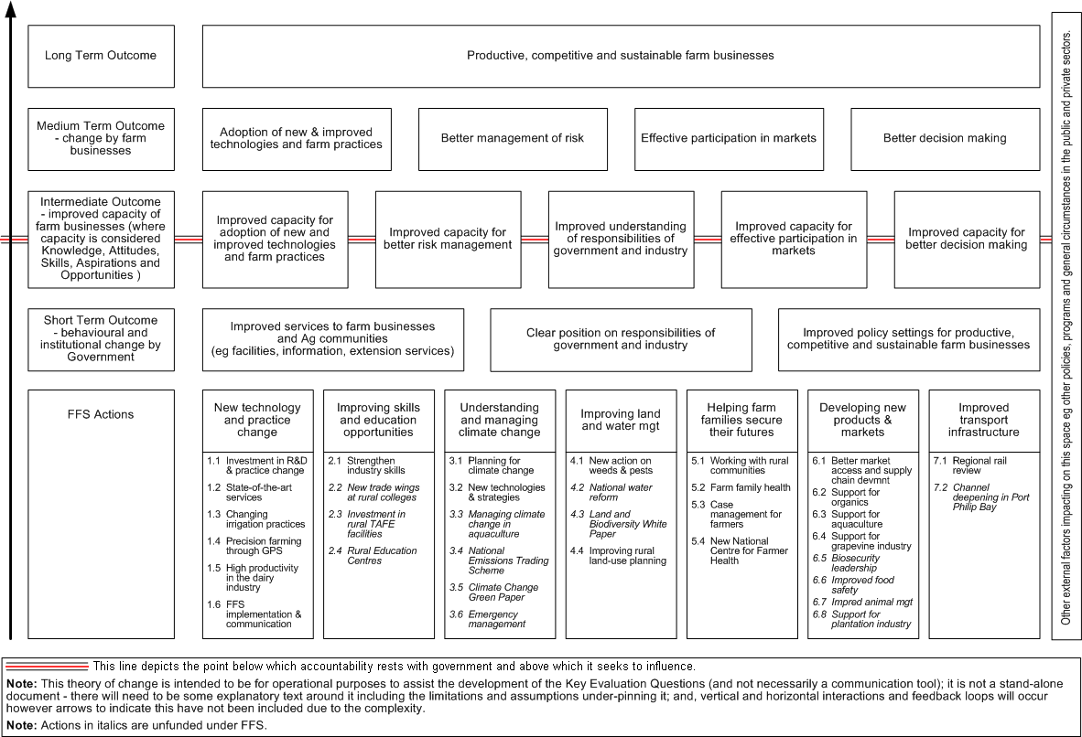
Victorian farm business and communities have been subject to the potentially long-term uncertainty due to the effects of the global financial crisis. International demand for some products has fluctuated dramatically, access to credit has become more difficult, and a decade of unprecedented dry conditions has seen zero water allocations for many irrigators. The looming threat of climate change has created uncertainty for agriculture. Coupled with a rapidly aging farmer demographic, the unfolding effects of technological innovation and the internet, increasing urbanisation of agricultural land and corporatisation of farm business, the consequences for the Victorian agriculture sector are unknown and unpredictable.

Complex interventions
Policy responses to complex issues increasingly recognise that joined up cross-government responses across multiple policy domains are required to achieve joined up solutions and address issues effectively. Long-term outcomes are sought, and attempts are being made to tackle root causes (Pinnegar 2006, Sanderson 2000). Such complex policy initiatives seek multi-level change within individuals, families, communities, businesses, services and systems (Barnes et al. 2003), and are implemented within a system of multi-level governance (Stame 2004). They have “many implementers, different beneficiaries, and different activities of the same beneficiaries, brought together in partnerships” (Stame 2004 p. 64).

According to Lewin et al. (2009), complex interventions include at least some of the following characteristics:

several elements that may act both independently and inter-dependently; complex systems or mechanisms for delivery of the intervention; an intervention that is difficult to describe and replicate; complex explanatory pathways; and a degree of uncertainty about the mechanism of action of the intervention or its ‘active ingredient’ (p. 1).

Interactions between complex systems and interventions
Complex interventions are events in systems, and as Hawe et al. (2009 p. 269) point out, it is not the intervention itself but the context or setting into which it is introduced and with which it interacts which is the most significant aspect of the complexity. Because they operate in complex systems, complex interventions are dynamic and are influenced by changing political and social contexts. They need to be adaptable to change and are inherently unpredictable (McLean et al. 2009, MacKenzie et al. 2010). Whether such interventions leave an enduring effect or fade without a trace will depend on how well the dynamic properties of the system are harnessed (Hawe et al. 2009).

The Future Farming Strategy can be considered a complex intervention introduced into a complex system. It is a joined up whole-of-government response across multiple policy domains. It is implemented within a system of multi-level governance, with individual Actions delivered by various departments, divisions, branches, programs and projects. FFS also draws in part on pre-existing services or ongoing research, making it difficult to define the intervention boundaries clearly.

The FFS attempts to address multiple aspects of the agriculture sector simultaneously, seeking synergies from the interacting component activities. This creates potential for both simultaneous and alternative causal strands, with different causal mechanisms operating in different contexts. The FFS broad, long-term outcomes of more productive, competitive and sustainable farm businesses are difficult to define in tangible terms. In all likelihood, actual outcomes will be emergent, non-linear, and disproportionate. It will also be extremely difficult to isolate the effects of the FFS from the effects due to interaction with other initiatives or with mainstream services.

Such complex interventions “present the greatest challenge for evaluation . . . because the path to success is so variable and it cannot be articulated in advance” (Rogers 2008 p. 31).

Role of program theory
Many evaluators advocate the use of program theory for evaluating complex interventions, although their approaches and the particular aspects of complexity they address differ. The language they use also varies between program logic, program theory, theory of change, and theory-based evaluation.

Douthwaite et al. (2003) successfully used program theory (what the authors refer to as an ‘impact pathway’) in their evaluation of a complex agricultural intervention. At the project level, a program theory was developed to model the explicit theory of how the project expected to achieve impact. While the logic model concentrated on detailing outcomes which linked project outputs to direct benefits for target groups, the authors claim it also helped understand how the direct benefits were impacting on higher order outcomes.

A theory of change approach was applied in the evaluation of the complex English Health Area Zones (HAZ) initiative. Judge and Bauld (2001) found that in practice, it proved easier to develop theories of change for individual HAZ projects than for the overall initiative. Discussing the same HAZ evaluation, perhaps with some benefit of hindsight, Barnes et al. (2003) argue that due to its inherent complexity, theories of change constructed for the HAZ initiative are bound to be incomplete, and add that:

“the linear logic implied by a theory of change approach, which requires pre-specification of how actions will lead to outcomes, cannot embrace the way complex systems actually work . . . they do not anticipate chance or radical change in context” (Barnes et al. 2003 p. 277).

Patton (2010) also comments on the limitations of logic models in unstable environments. Logic models describe the evaluand, what Patton refers to as the IT, and he claims “the very notion of an IT connotes a static, fixed mechanical cause-effect model . . . (which has) . . . significant downsides and distorting effects in complex and dynamic situations where the IT is emergent, evolving and adapting” (Patton 2010 p. 18).

Rogers (2008) suggests that the use of simple, linear logic models should be restricted to aspects of interventions that are tightly controlled, homogenous and well-understood, or where a general notion of causal intent rather than an accurate model is required. When dealing with complex interventions with emergent outcomes, she proposes that an emergent logic model which continually evolves, or a series of logic models reflecting changes in understanding, may be required. For complex interventions requiring a common framework across all projects for vertical and horizontal synthesis, she suggests the ideal overarching logic model would need to be generic enough to be relevant for a wide range of projects while at the same time be able to incorporate specific emergent outcomes as projects evolve, reacting to issues and opportunities (Rogers 2008 p. 42).

A strong foundation for the FFS evaluation is provided through the widespread use of logic models at the Action level. However, while these show an attempt to outline the assumed linkages among inputs and outcomes, they generally do not consider the underlying mechanisms that are presumed to be responsible for those linkages, and several also lack what Douthwaite et al. (2003) call the ‘hypothetical bridge’ which helps to understand how the direct benefits at the Action level impact on the higher order FFS whole-of-strategy outcomes.

The logic model developed for the FFS whole-of-strategy level (Figure 1) is simplified and does not specifically consider the generative mechanisms or substantive theories involved in effecting outcomes. It does, however, provide a general notion of causal intent, offering a common framework for the multi-level FFS evaluation. It has also proved to be extremely valuable as a tool upon which to base evaluation discussion with Action teams and to communicate the concept of FFS to stakeholders, including the primary evaluation audience.

Audience expectations
An additional aspect which makes the FFS evaluation a complex enterprise concerns the expectations of the evaluation audience, including reaching agreement on whether judgements of adequacy are necessary, the extent to which ‘global’ net benefits can be determined, and the level of confidence required that any observed effects were in fact caused by the intervention.

Assessing adequacy (whether achievements are sufficient) assumes the existence of some agreed success criteria. As yet, no such criteria or targets have been agreed for FFS. FFS outcomes are expressed in nonspecific terms, and these may be purposely so “to preserve needed managerial and political flexibility” (Smith 1994 p. 85).

Net benefit studies involve establishing a counterfactual argument, assessing what would have happened without the intervention. Rogers (2008) suggests that the counterfactual argument maybe inappropriate when interventions have different causal mechanisms operating in different contexts, because there are alternative ways of achieving outcomes. For this reason, net benefit analyses are proposed for component projects of FFS where known causal processes are clearer and more direct.

Funnell and Rogers (2011) offer a framework for causal analysis using program theory. They suggest an approach consisting of three components: congruence, which assesses whether the results match the program theory; counterfactual comparison, which assesses what would have happened without the intervention; and critical review, which assesses whether there are other plausible explanations of the results.

This approach is predicated on having a strong program theory, and would rely more on qualitative, descriptive methods to articulate a plausible narrative for FFS’s contribution to outcomes. Without clearly definable intervention and control groups, and the impossibility of establishing randomised control trials due to the porous boundaries of the FFS, it would be unrealistic to expect any higher level of confidence.

This view is echoed by Molas-Gallart and Davies (2006) in their review of the literature and practice concerned with the evaluation of complex science, technology, and innovation policies. Commenting on the challenges involved in causal assessments of such complex initiatives, they conclude:

The main problem here is that we are trying to measure the exact extent to which specific outcomes can be attributed to policy measures, which are likely to play a small role among the many other factors that will emerge in a systemic model. Such detailed attribution requires comprehensive modelling and measurements that are not currently available (p. 78).

Sanderson (2002), commenting on the new enthusiasm for evidence-based approaches to public policy, identifies a “dominant rationalist-modernist paradigm” which he argues “has given a new lease of life and purposefulness to preoccupations with measurement, traditional worries regarding reliability and validity, and other concerns captured within quantitative methodology” (p. 436). Qualitative methods are advocated by many authors as appropriate, or even necessary, for evaluating complex interventions (Mayne 1999, Judge & Bauld 2001, Stame 2004, Rogers 2008, Patton 2010).

Again, robust discussions with the primary evaluation audience will be required to reach agreement regarding the evidence feasible for the FFS evaluation. As Molas-Gallart and Davies (2006) warn: “The tension between the systemic evaluation approaches proposed by evaluation experts and the impact measurements required by clients for accountability purposes is not going to be solved easily” (p. 78).

Planning the FFS evaluation
The purpose of the overall FFS evaluation effort is to:
- Examine if the FFS has made progress towards improving the productive, competitive and sustainable status of Victorian farm businesses;
- Assess the benefits of Victorian Government investment in the FFS; and
- Provide opportunities for learning and improvement in whole-of-government strategy implementation and delivery to guide future policy and program development.

The following section discusses the implications of complexity for each cluster of key evaluation questions and how these implications influence evaluation planning decisions concerning the choice of methods and the level of evidence that is feasible.

FFS contribution to outcomes identified in the logic model
Outcomes at all levels of the logic model are described generically. Negotiations are progressing with the primary evaluation audience regarding how these outcomes are to be defined, how success will be measured, and how adequacy will be judged. The use of rubrics is being investigated (Davidson 2005), although ‘retrofitting’ success criteria might be problematic and would require a significant investment of time and resources.

Although the FFS evaluation is based firmly on logic models at all levels, there is a need to ensure casual mechanisms and linkages are examined. Action level evaluations are making more effort to use their logic models to plan and implement their evaluations and paying greater attention to the underlying casual mechanisms. This should improve the strength of the hypothetical bridge between Action outcomes and higher-order strategy level outcomes.

Agreement must be reached between the types of evidence desired by the evaluation audience and the feasibility of obtaining it. Experimental or quasi-experimental evaluation designs are not appropriate for the complex FFS evaluation. An approach informed by Contribution Analysis is being explored, whereby uncertainty regarding the effect a program is having on observed outcomes is reduced by providing plausible evidence of program contribution and reporting this argument through a performance story (Mayne 1999).

Due to their diverse nature, it is highly unlikely that aggregation of outcomes across Actions will be possible. Therefore, strong alignment between Action level program theory and strategy-level program theory will be needed to link Action outcomes to higher order FFS outcomes. Again, well coordinated flows of evaluation information will be required.

A focus is needed on the underlying mechanisms operating within FFS and the conditions under which they are activated. This will be important for understanding how and why change is or is not occurring. It will include paying attention to feedback loops, tipping points, simultaneous or alternative causal strands, emergent outcomes, synergies between Actions, global and local dynamic contexts and external factors influencing the achievement of outcomes. Many of these elements will be best identified at the Action level as they will be more familiar with the contextual factors affecting their particular domains, so it will be necessary to ensure these considerations are included in Action level evaluation planning.

Return on government investment in FFS
Return on investment will be addressed through a suite of Net Benefit case studies. Case studies have been selected from component projects which have some less complex aspects where causal processes are identifiable and counterfactual comparisons are feasible.

Learnings
An intentional process must be in place to ensure learnings are captured. Learnings include those relevant to FFS, future policy responses and complex evaluations, and these will be captured at all levels of FFS and disseminated to appropriate audiences so their utilisation can be maximised.

Conclusion
As policy interventions become more complex, designed to address issues in a holistic way to deliver broad, long-term outcomes, the evaluation challenge is becoming as complex as the interventions to be evaluated. If such evaluations are to be influential, the implications of complexity must be appreciated and allowed to shape evaluation designs.

Negotiating issues of scope, how success will be defined and how it will be measured become critical, and will certainly involve some form of compromise between what is deemed credible and what complexity renders feasible.

There is no magic formula for evaluating complex strategies. Complexity dictates that each scenario has its own particular dynamics. In order to develop a plausible explanation of the impact of FFS, it will be important to understand the underlying mechanisms and contextual interactions which contribute to the achievement of outcomes at all levels of FFS. This will require a theory-oriented approach to evaluation at all levels, and the provision of appropriate support for Action teams to secure their cooperation and ensure they have the necessary evaluation capability.

References
Barnes, M., Matka, E. and Sullivan, H. (2003). Evidence, understanding and complexity: evaluation in non-linear systems. Evaluation 9(3), 265–84.

Davidson, E. J. (2005). Evaluation Methodology Basics: The Nuts and Bolts of Sound Evaluation. Thousand Oaks, CA, Sage.

Douthwaite, B., Kuby, T., van de Fliert, E. and Schulz, S. (2003). Impact pathway evaluation: an approach for achieving and attributing impact in complex systems. Agricultural Systems, 78, 243-265.

DPI. (2008). Future Farming: Productive, Competitive and Sustainable. Department of Primary Industries, Victoria.

Funnell, S. and Rogers, P. (2011). Purposeful Program Theory: Effective Use of Theories of Change and Logic Models. John Wiley/Jossey-Bass, CA.

Hawe, P., Shiell, A. and Riley, T. (2009). Theorising interventions as events in systems. American Journal of Community Psychology, 43, 267-276.

Judge, K. and Bauld, L. (2001). Strong theory, flexible methods: evaluating complex community-based initiatives. Critical Public Health, 11(1), 19-38.

Lewin, S., Glenton, C. and Oxman, A. (2009). Use of qualitative methods alongside randomised controlled trials of complex healthcare interventions: methodological study. British Medical Journal, 339, b3496.

MacKenzie, M., O’Donnell, C., Halliday, E., Sridharan, S. and Platt, S. (2010). Do health improvement programmes fit with MRC guidance on evaluating complex interventions? British Medical Journal, 340, c185.

McLean, R., Hoek, J., Buckley, s., Croxson, B., Cumming, J., Ehau, T., Fa’asalele Tanuvasa, A., Johnston, M., Mann, J. and Schofield, G. (2009). “Healthy Eating – Healthy Action”: evaluating New Zealand’s obesity prevention strategy. BioMed Central Public Health, 9, 452.

Mayne, J. (1999). Addressing attribution through contribution analysis: using performance measures sensibly: discussion paper. Office of the Auditor General of Canada, June.

Molas-Gallart, J. and Davies, A. (2006). Toward theory-led evaluation: The experience of European science, technology, and innovation policies. American Journal of Evaluation, 27(1), 64-82.

Patton, M. (2010). Developmental Evaluation: Applying Complexity Concepts to Enhance Innovation and Use. Guilford Press, NY.

Pinnegar, S. (2006). Are complex programs the best response to complex policy issues? City Futures Research Centre Issues paper, Kensington, NSW: University of New South Wales.

Rogers, P. (2008). Using programme theory to evaluate complicated and complex aspects of interventions. Evaluation, 14(1), 29-48.

Sanderson, I. (2000). Evaluation in complex policy systems. Evaluation, 6(4), 433–454.

Sanderson, I. (2002). Evaluation, policy learning and evidence-based policy making. Public Administration, 80(1), 1-22.

Smith, N. (1994). Clarifying and expanding the applications of program theory-driven evaluations. American Journal of Evaluation, 15, 83-87.

Stame, N. (2004). Theory-based evaluation and types of complexity. Evaluation, 10(1), 58-76.

The term ‘Action’ is used throughout the official FFS documentation. It loosely translates to ‘project’, although FFS Actions range from small single issue projects to large programs comprised of multiple projects. As a thematic construct, individual Actions were grouped into seven Action Areas by the FFS designers (see Figure 1).

