MONITORING AND EVALUATION IN THE BUILDING AND CONSTRUCTION SECTOR:
A BRAVE NEW WORLD

Australasian Evaluation Society Conference 2011

A. Duncan¹
¹Department of Building and Housing, New Zealand

Introduction
The Department of Building and Housing is the New Zealand government agency responsible for improving building quality and housing availability in New Zealand. It was set up in 2004. [Slide 2]

The Government's medium-term priorities for the sector are to:
- support rebuilding and recovery in Canterbury
- provide effectively for those most in need of housing assistance through the right products and services
- develop innovative policy and approaches to housing and building supply and affordability
- work in partnership with third party providers to transform the social housing sector and improve availability of social housing
- develop a sector skills strategy with agreed productivity goals and targets
- implement agreed changes from the Building Act 2004 review
- achieve greater efficiency, effectiveness and alignment of trade licensing boards in the sector
- improve transparency of the cost to deliver Crown-funded programmes.

Our Big issue [slide 4]
New Zealand was hit hard by the impacts of failed weathertightness. [slide 5]The flow on effect to the sector was huge. 42,000 homes between 1992 to 2008 were affected by trapped water rotting house structure. PWC estimates an $11 billion cost to fixing the problem. At the minimum end of the damage scale, this trapped water rots your wallpaper. At the other end, it can turn your framing into paper mache.

The Government had to respond, and they did so by introducing many changes to the regulations surrounding building and housing. They passed the Building Act 2004 and set up the Department of Building and Housing in 2004 as part of this response. They also set up the Weathertight Homes Resolution Services (WHRS). As part of the drive to reduce sector regulation, they put in place a review of the Building Act. The review began in 2009.

In thinking about designing and evaluation approach, it is important to consider that a residence or office block is more than a building for most New Zealanders. Buildings and construction shape the way our cities look, they impact on our communities’ sense of cohesiveness and provide vital services that keep our country working. [slide 6, 7]

A home is not just a house. It is where we live, enjoy our family, and share our lives. Building and construction shapes the way our cities look and function. Buildings impact on our sense of community and cohesiveness. Buildings provide vital services that keep us working.

The challenge to the Department now is how to measure the impacts of these changed policies, regulations and processes. [slide8] The key questions are:

- How do we know if this response has worked, and, if so, to what degree, where and for whom?
- Can we use traditional evaluation approaches in this work? If not, why not, and what approach should we use?

Traditionally, evaluation of building and housing was a relatively simple one, buildings stood up or they didn’t. [slide 9,10 and 11] Further, more traditional evaluation has focused on programmes and social or behavioural change. This evaluation sits in what has generally been considered to be an economic area – construction. That said, an understanding of the social value of housing has been well understood for some time.

A new evaluation approach has had to be developed. [slide 12]

The key concept I want to talk about here is that new types of evaluation present new challenges including:

- Understanding of the function of evaluation and how it can add value in this situation
- Using evaluation to both educate and enable participants to take more responsibility for the work they deliver
- Using evaluation to bridge the relationship gap across government, industry leaders and businesses, providers of building and construction services, and the public – the end-users of these services.

A big challenge has been figuring out how evaluation can work when everyone has a different definition of success. This is primarily an evaluation of regulatory change. Evaluation of regulation interests a wide range of people.

- Government is concerned with cost-effectiveness and whether policy objectives have been achieved or not.
- industry and business are concerned with safety and standards,
- those working in the sector are concerned about income and job security, and
- the public are concerned about spending their money wisely when they invest in either a commercial or residential building project.

How can evaluation work when everyone has a different definition of success?
If we go back to that list of people who all have a stake in the building and construction sector and look more closely we begin to be able to separate out the issues. They are:

(a) Government is concerned with cost-effectiveness and quality: The Department is a government agency, and we are public servants. The government regulates the sector and sets the standards that buildings have to meet.

(b) Industry and business are concerned with safety and standards: For those running projects they need to know they are working within our safety standards and regulations as described in the Building Code. They are also concerned with delays that might be caused by enforcing those regulations, because that costs them money.

(c) Those working in the sector are concerned about income and job security. For those working in the construction sector it’s their livelihood. They need to know there is steady work and a steady income stream as well as career progression options.

(d) The public are concerned about spending their money wisely when they invest in either a commercial or residential building project. As the end users and owners of the product, the public wants a fit for purpose building that complies with the building code. They don’t want to be delayed by regulations or industry issues and they want to know they are getting the best product for the best price.

There is also no way to argue which is more ‘important’ as they all impact on each other. This almost circular effect is the reason we find ourselves unable to use more traditional goal based evaluations and why we must look to something more like Developmental evaluation which is able to change and respond as the work programme makes changes and responds.

Moving into this brave new space of evaluation for the building and construction sector the first thing to identify was a programme to evaluate. That’s the easy part. I decided to focus on evaluating the Building Act Review.

Building Act Review 2004 – what is it? [slide]
A significant stream of work for the Department is implementing changes from the Review of the 2004 Building Act (BAR).

My first question was “what is the BAR and what was the reason for it?”

“The BAR was intended to address a range of concerns about the existing building consent process, as described in the Regulatory Impact Assessment.
- Delays and high costs to consumers, builders, consent authorities
- Regulatory oversight is not matched to building risk levels
- Risk-averse regulatory approach is believed to lead to delays, and to discourage innovation
- Inconsistencies in regulatory approaches and requirements across territorial authorities
- Need for better accountability by building providers, and better informed decisions by purchasers

Baseline information about the quality of building in NZ and the efficiency of the regulatory system is patchy, inconsistent, and sometimes anecdotal, which limits the potential for detecting changes in attitudes or behaviours.”

To start our evaluation, my team and I worked out what the BAR trying to achieve i.e. to find out the purpose for the reforms and activities. We could then understand the intervention logic behind the programme.

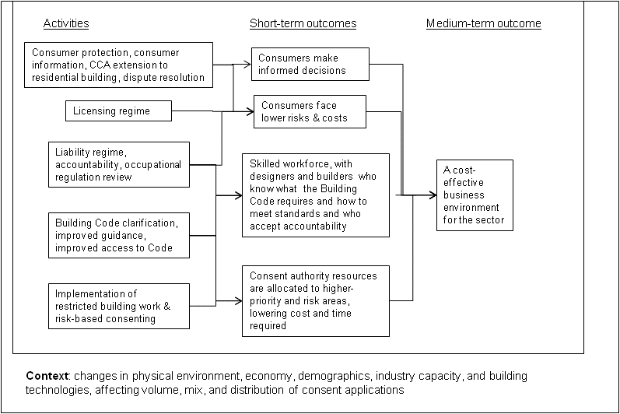

Summary of Aims of BAR [slide]
“Review of the Building Act 2004 aims to reduce the costs, but not the quality, of the building control system, to achieve the following results:

- Quality homes and building are produced through a business enabling and efficient regulatory framework
- Consumers can make informed decisions and have confidence in transacting in the building and housing market
- Homes and building are produced cost effectively by a productive sector who have the right skills and knowledge
- The regulatory system is administered in an efficient and cost effective manner.”

BAR Workstreams [slide]
The work has been divided into four workstreams:

- Accountability – everyone knows their rights and responsibilities
- Consumers – consumers take ownership
- Sector skills and productivity – the sector has the skills to do the job right the first time
- Regulatory system design – the system is nationally consistent and efficient
- Stakeholder engagement and communications – people know what they need to know

The BAR is a complicated set of projects that combine in a single programme of work or system, as set out below. [slide]

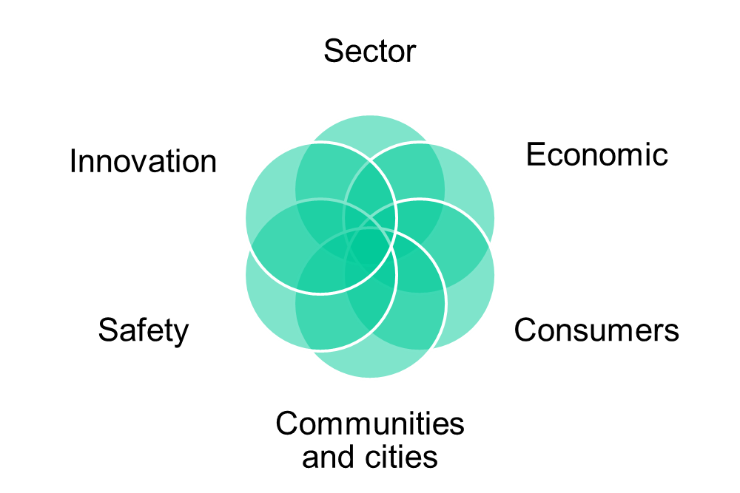

Developing Measures [slides]
As a first step, we identified a series of measures for the evaluation which were linked to each of the workstreams.

Accountability
- Implementation of nationally consistent streamlined process
- Time and cost of consent processing, by risk category

Consumers:
- Confidence in providers
- Use of formal contracting
- Satisfaction with building results
- Volume of disputes
- Level of Building Act or Building Code enquiries

Sector Skills and Productivity
- Number of Licensed Building Practitioners by license class and region, as proportion of requirements
- LBP success rate in passing building inspections
- Level of rework required

Regulatory System Design
- Clearer Building Code guidance
- Improved access to Building Code System information
- Implementation of risk-based consenting system
- Time and cost of consent processing under risk-based approach
- Building quality changes under risk-based approach: numbers of consent refusals, numbers of failed or repeat inspections, proportion of applications considered deficient

It’s Not Simple!
It is easy to identify from this list that none of these areas exists within a vacuum and any changes made to one could impact on any or all of the rest. They are inter-related to the point of co-dependency. How do we understand and account for that?

Ay, there's the rub. [slide]

It seemed that our simplistic approach wasn’t really going to tell us how well or otherwise the various programmes were delivering their aims. The issues I identified were co-dependency and complexity.

Co-dependency
The programmes were inter-related to such an extent that it seemed to me impossible to separate out the impacts of any one of them. Any changes made in one workstream could impact on any or all of the others.

Complexity
The programmes were being led by individual work stream leaders who did not have, as I saw it, a systems overview. That is, I wasn’t convinced that they understood the complex set of interactions and inter-impacts (is there such a word?) that were going on

The measures we identified seemed to simplistic. I wasn’t convinced that they could capture the reality of the situation and tell us what, if anything, was changing.

Once I had identified these issues, it became clear that we needed to consider the BAR as a complex adaptive system – something that was changing and adapting all the time. As articulated by Patton, if we focus too much on measuring simply the goals of programme in evaluation, we will miss the unanticipated effects.

Risks
The BAR programme is making huge changes across a number of area of the building and construction sector. To miss the unintended consequences of these changes, or the flow on impacts, would be disastrous.

The key risks were:
- Interdependencies of workstreams
- Political landscape
- Cost
- Scope

The main risk was interdependency. I consider the interdependencies to be the main project risk, and it is so because of the highly dependent nature of our ability to measure and evaluate when related to the individual workstream planning and work programmes. Currently they are at various stages of development. We cannot lead the programme. We can inform programme development, and we do where we can and where we are asked to. For the most part, however, we follow the programme. I often think of evaluation as the shovel that goes behind the horse and cart. Say no more.

Political landscape: [slide] The political landscape is our second most concerning risk. Working with 69 BCAs (Building Consent Authorities) across New Zealand is interesting. Each BCA is part of a Territorial Authority or local town or city council but they are all administering one national Building Code. The landscape at present is a varied. One of our first projects is to put together a stocktake of current practices so at least we know where we are starting from. That always helps when trying to measure how far you have come!

Cost and Scope are usual project risks that can be managed. The key mitigation is to ensure you are aware of costs and scope as you progress so you can respond early.

So, really we are coming back to an issue of how we think about building and construction. We talk and think about the sector as building - order the right amount of wood, enough nails and get someone to bang them together.

The competing goals of those involved in building and construction sector, economics tied with safety ties with innovation tied with a sense of community and sustainable cities – these are not things that can be measured with a simple pass/fail approach to goal evaluation.

When approaching the BAR evaluation the issue was actually me. I didn’t understanding the complexity of what we were undertaking. The brave new world is not the BAR per se, the brave new world is how I as evaluator understand and manage the competing needs of an industry that affects so many other parts of our larger society.

So what does the evaluation look like now?
In the first instance, like any good evaluators, we are interested in getting baseline data from which to measure success as the programme continues. The BAR monitoring and evaluation currently consists of:

- Consumer satisfaction survey
NRB has been contracted to conduct a telephone survey of consumer satisfaction with building services. We hope to repeat this survey on a yearly basis and see the changes from the BAR reflected in increased customer satisfaction.

- Key statistics dashboard
Monitoring baseline data monthly on processing of building consents, number of Licensed Building Practitioners, consumer awareness and consumer attitudes etc.

- Scanning changes in the consenting process
Working through the websites of current Building Consent Authorities to monitor any proactive changes to their consenting systems and collect baseline data. Those who are taking a proactive change are likely to be approached for interviews.

- Case studies
Christchurch and possibly one other centre are piloting ‘risk based consenting’. We will use case studies to evaluate the pilot and make any changes before the process is rolled out nationally.

Onwards and upwards
I am confident that we can meet this challenge as it unfolds. My confidence is based in the following;

- Our ability to be flexible and adjust our programme of work or even, if necessary, our programme intervention logic
- Our ability to support and empower the work of others as they develop their workstream programmes. We do this through developing and maintaining good, positive working relationships.
- Our commitment to monitoring and assessing our own performance as an evaluation team
- our ability

And after that?
Well, we will wait and see. Another brave new world is just over the horizon.

I’ll let you know how we go.

Taken from Regulatory Impact Assessment (RIS) associated with this Cabinet paper.
Taken from a Cabinet paper in 2009.
From Hamlet 3.1 by William Shakespeare
Patton, M., Q. (2008) Utilization-Focused Evaluation 4th Edition. Sage Publications: United States of America

